In GIT-hub:

Creating a public repo and having branch_ deploy.

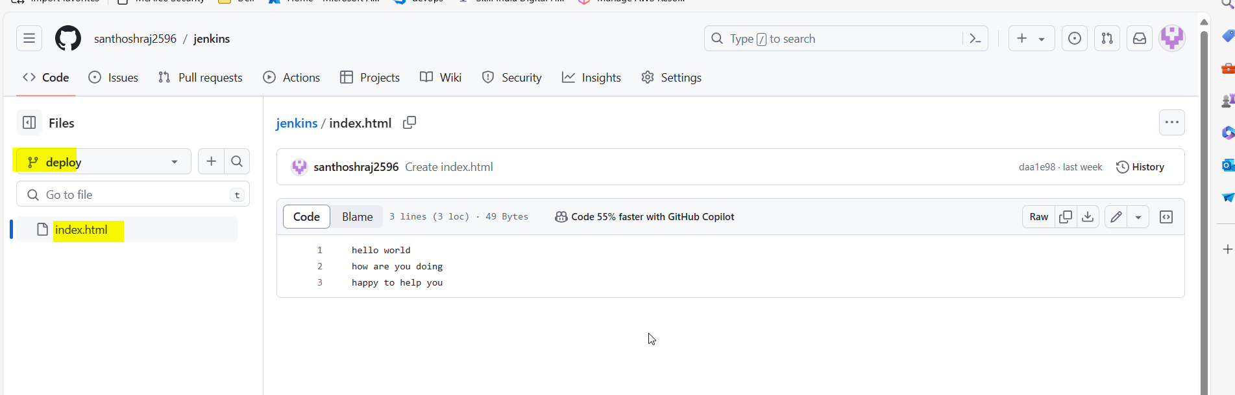

Creating a Project in Jenkins:

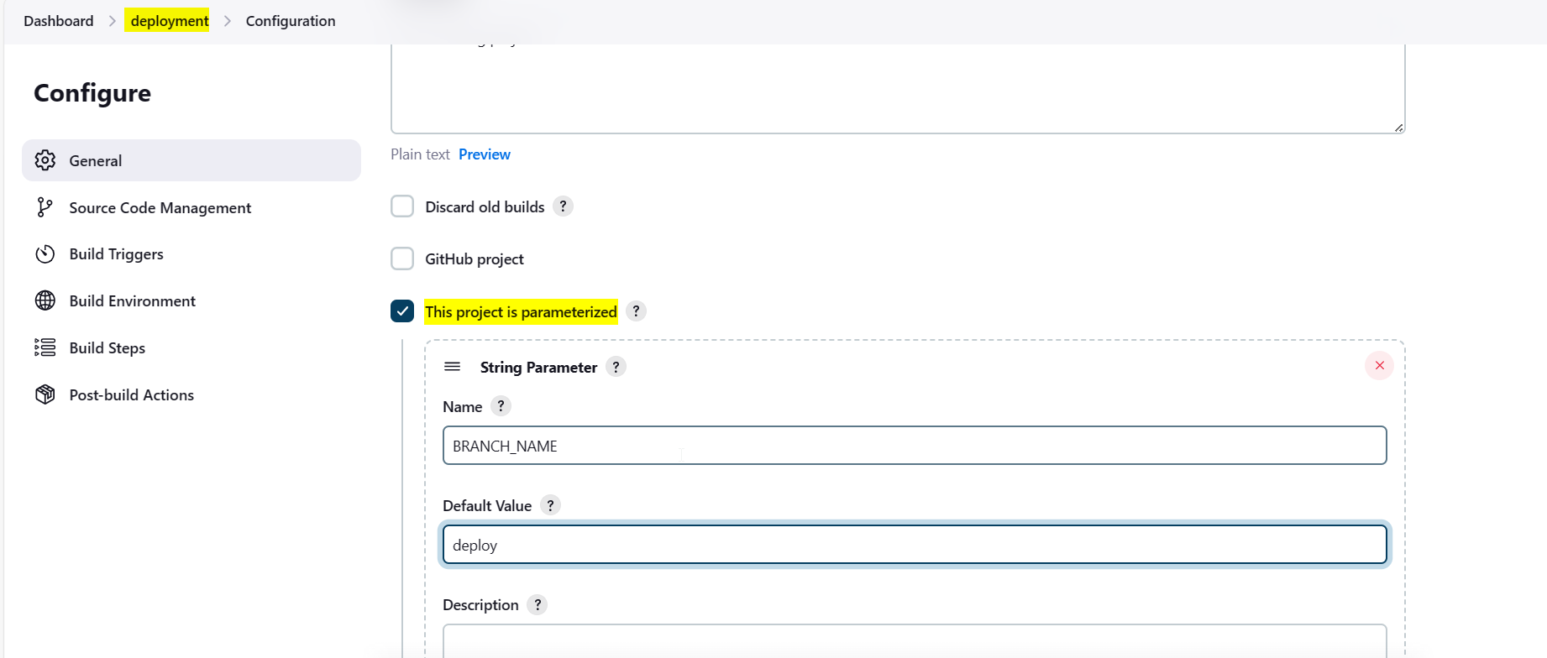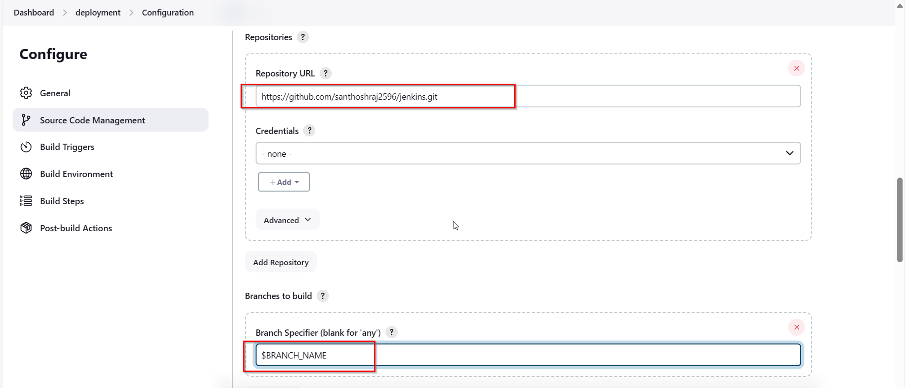

Setting Git commit pull for every minute when there is changes made.

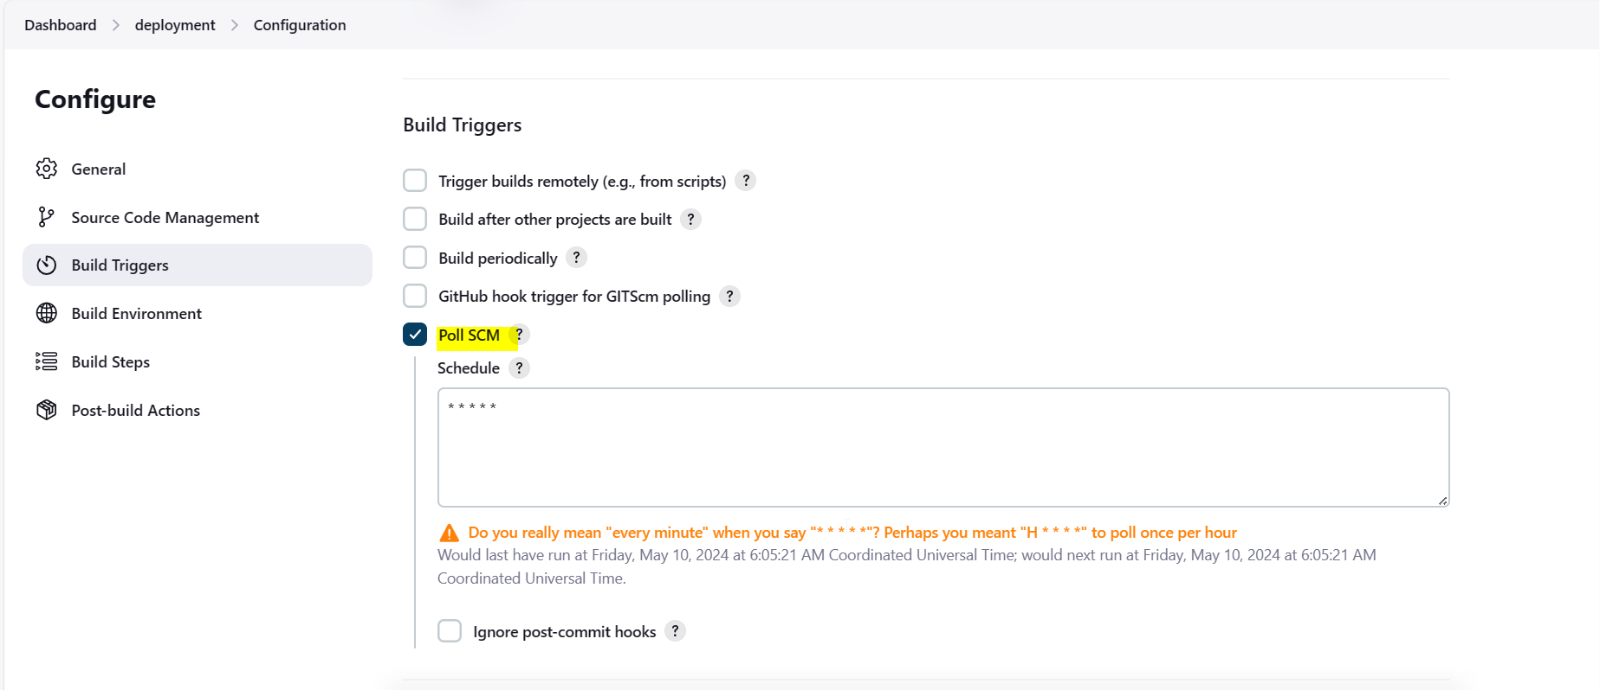

Creating Global secret file:

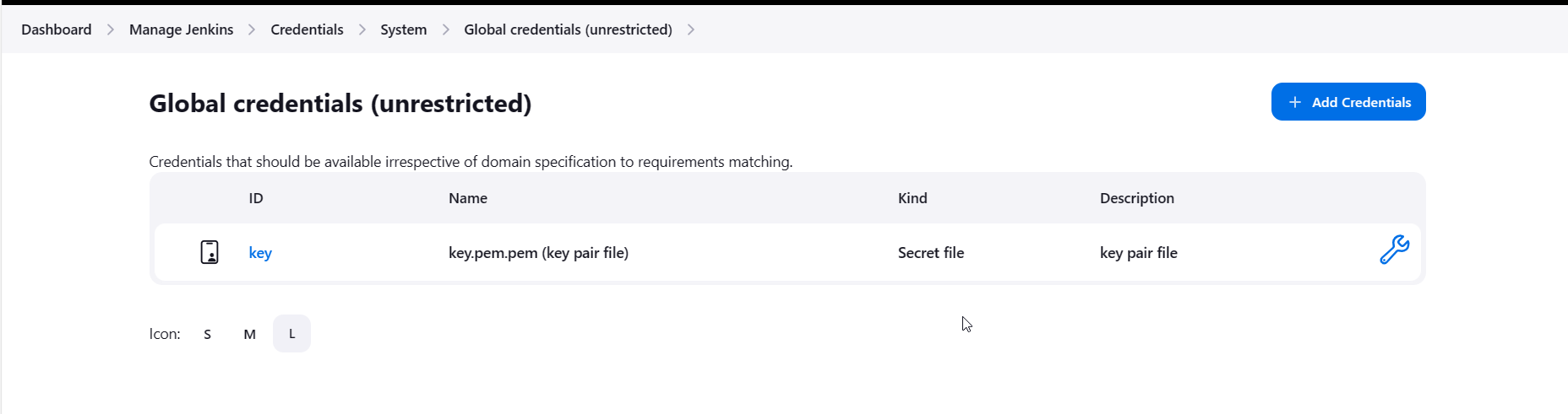

In Execute shell, providing command to auto deploy in /var/www/html default web server path for nginx to pick and show in browser. 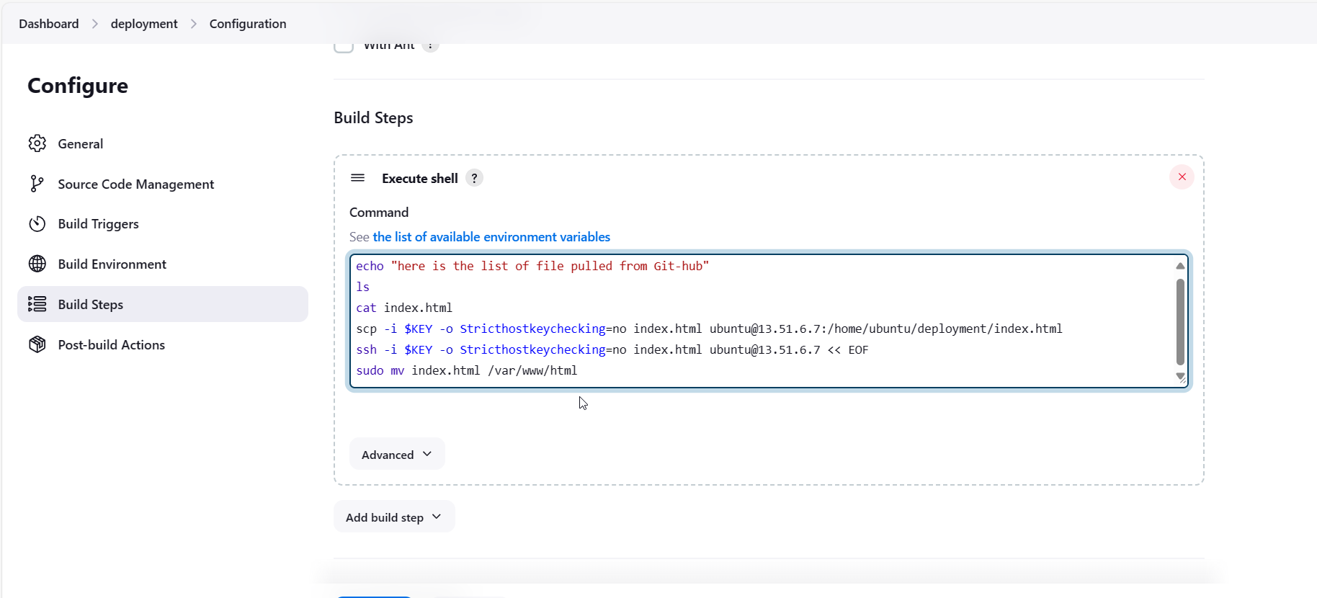

Building now:

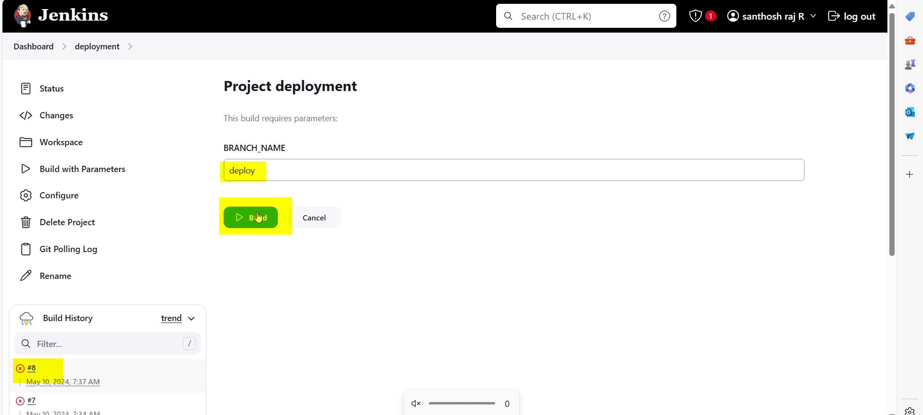

Facing this error.

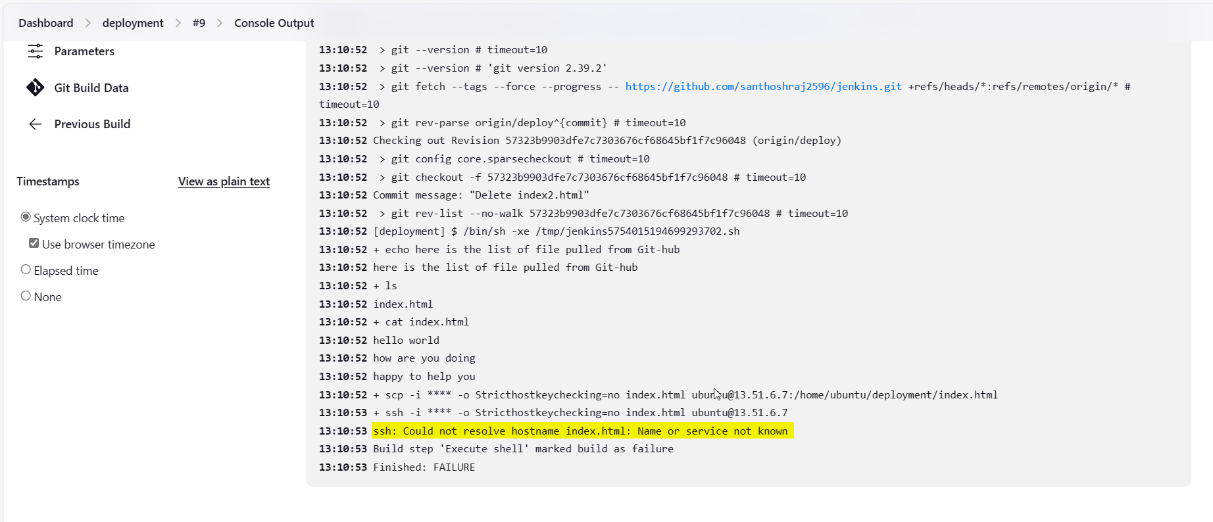

But when we commit any changes in Git Hub build is running. 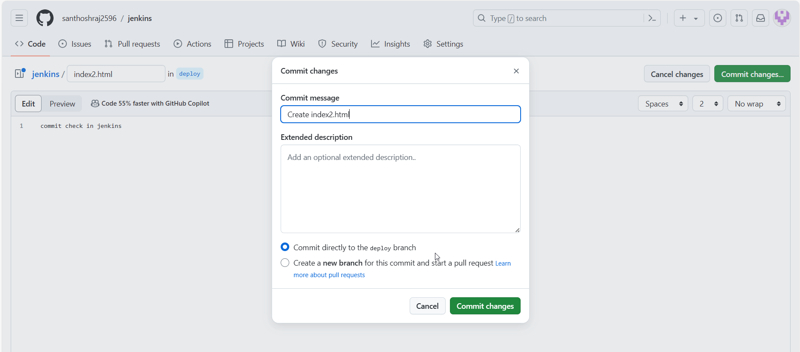

Build auto runs:

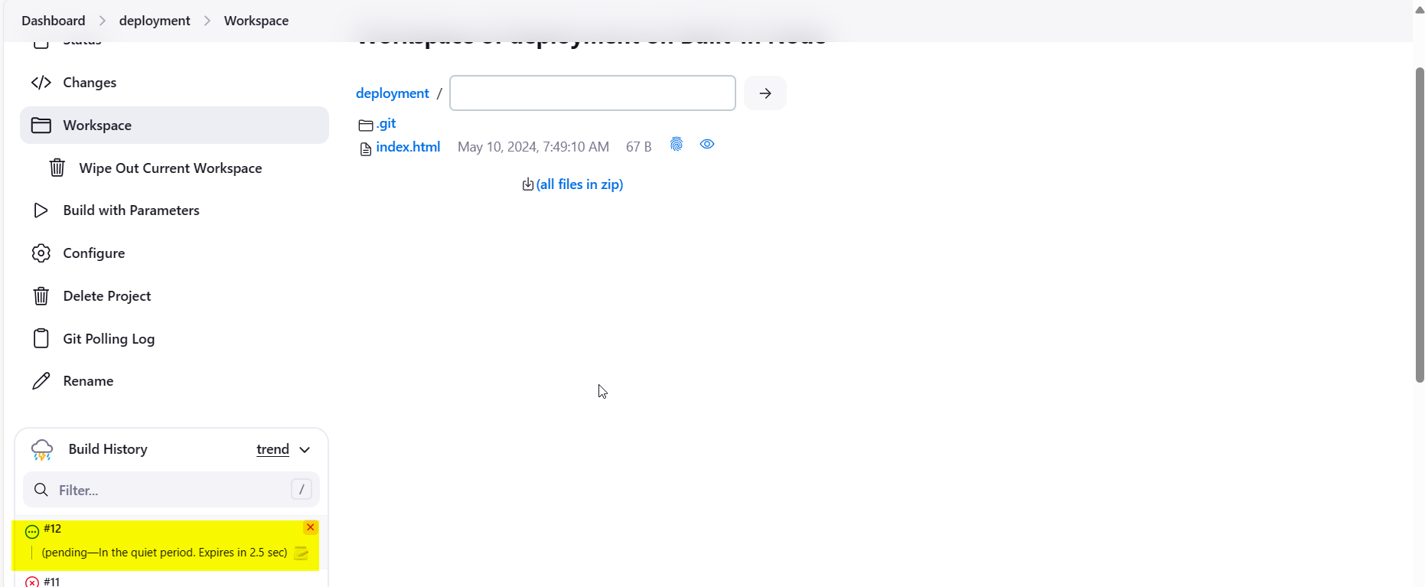

In workspace also index2.html is available:

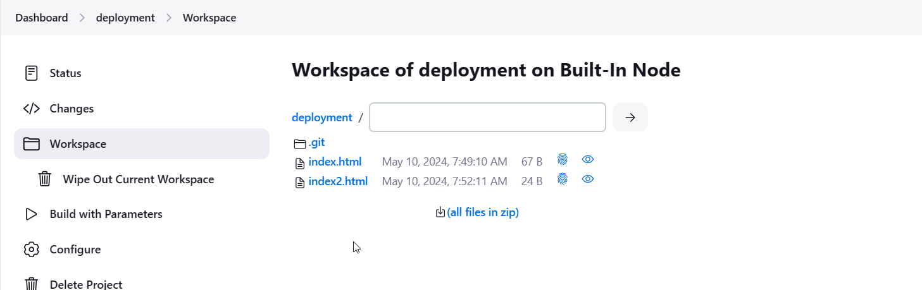

If we remove the SCP ,SSH to copy to server, then Build works fine. 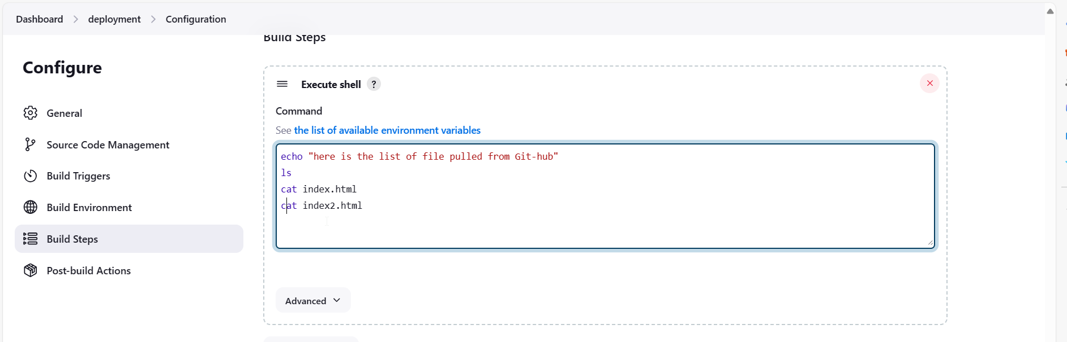

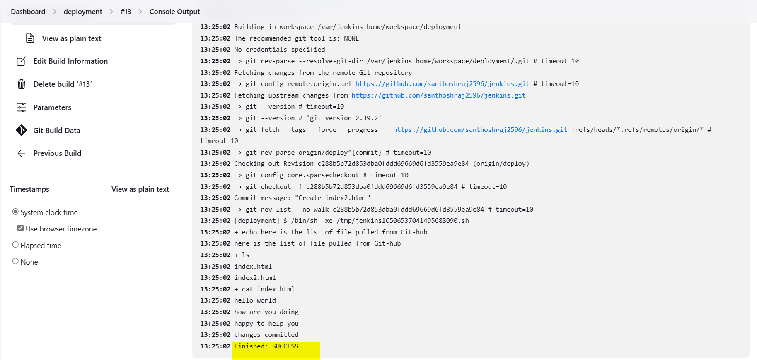

If we commit any changes in Git-hub ; branch: deploy:

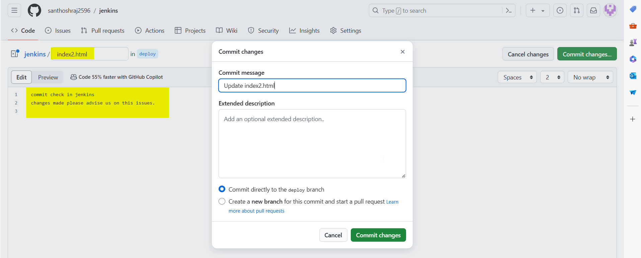

Build runs by SCM. 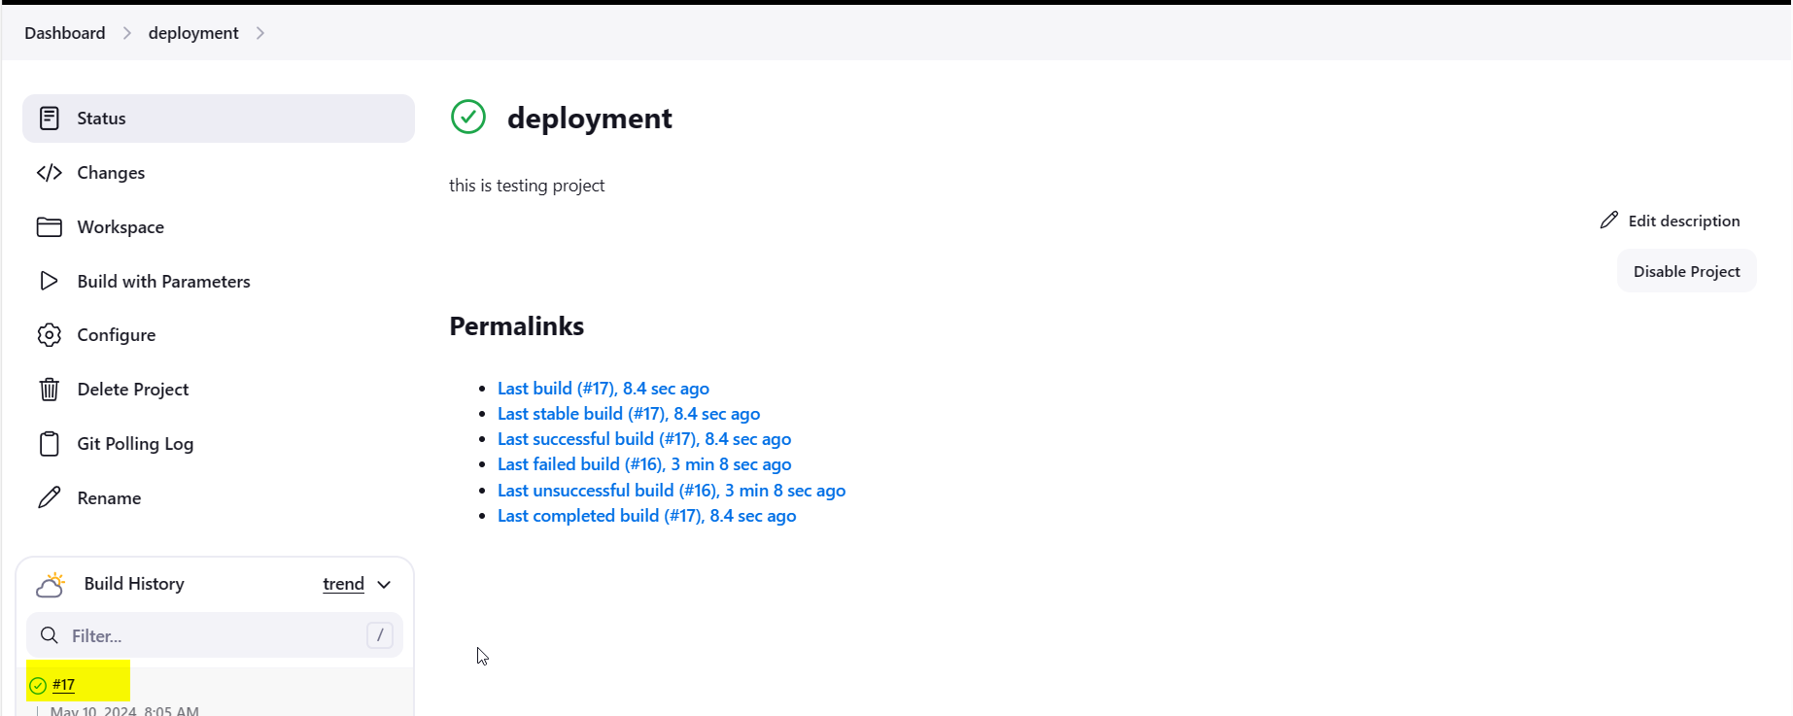 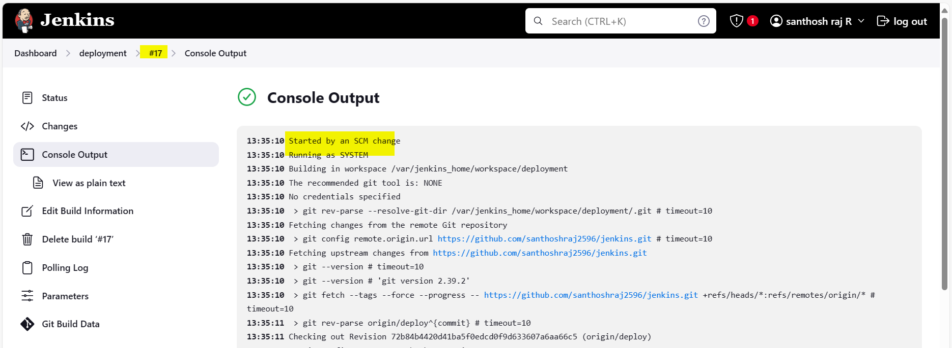 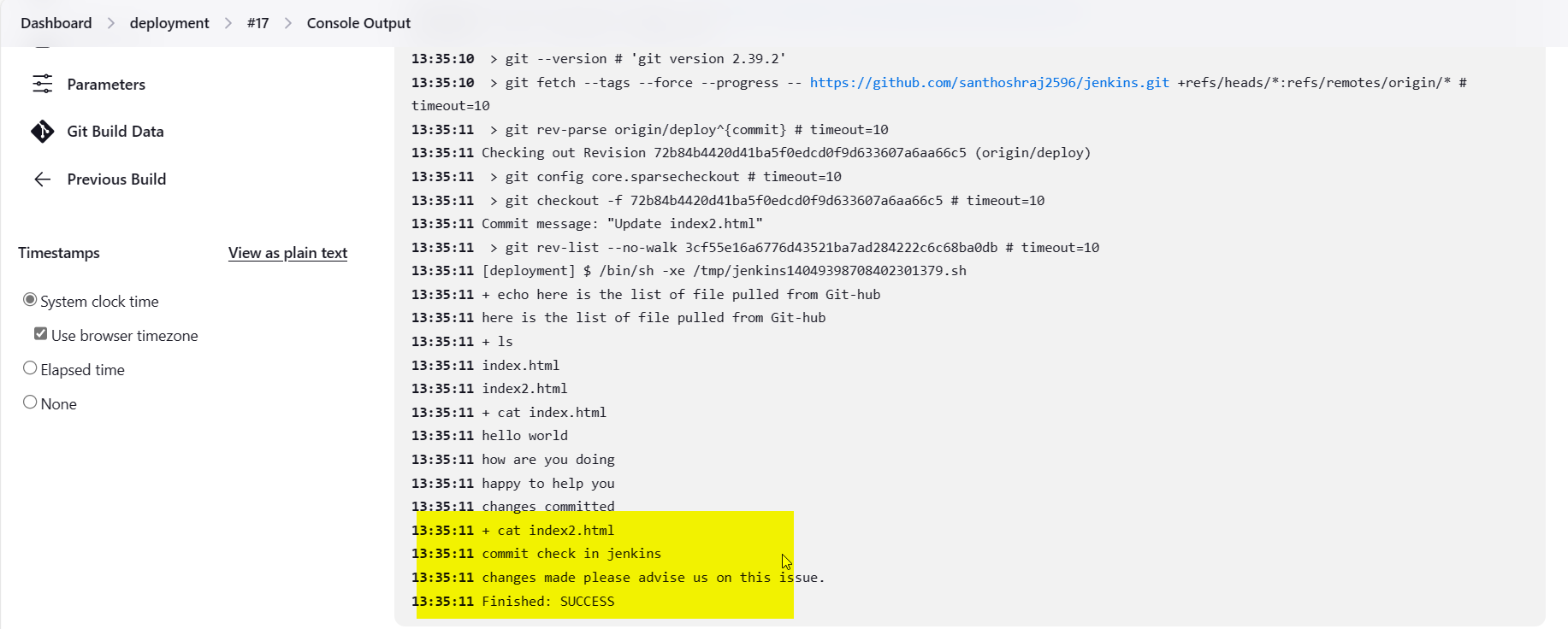

Email configuration is not taken yet.

Also not able to clear the Host service not known error.